SMA-CLMPNet: Spatial Multiscale Attention enabled Convolutional Distributed Memory Network for intra-frame video forgery detection
Abstract
Video forgery detection presents a vital threat to digital media authenticity because it allows harmful modifications through deepfakes, splicing, and frame duplication methods. Earlier techniques lack the sufficient capability to capture long-range temporal dependencies and maintaining cross-channel correlations which degrade their detection performance. Therefore, detection is an essential requirement for forensic investigations as well as journalism operations and legal court systems. Hence, this research proposes a Spatial Multiscale Attention coupled Convolutional distributed Long Short-Term Memory based Modified Pooling Network (SMA-CLMPNet) for detecting intra-frame video forgeries. The framework includes SMA mechanisms that optimize and process spatial, channel, and multi-scale features to capture complex forged patterns. Additionally, the inclusion of distributed LSTM and modified pooling techniques in CLMPNet addresses temporal inconsistencies by selectively aggregating the most informative features while reducing the loss of critical information. Collectively, these approaches allow the framework to advance the field of video forensics by addressing effective dependencies and various aspects, while extracting discriminative features, creating trust for verification of video authenticity across applications. The experimental results are analyzed using the Face Forensics++ dataset. At the training percentage of 90%, the framework attained an accuracy of 97.92%, sensitivity of 97.34%, and specificity of 98.20%, respectively showcasing it as the prominent solution for detecting manipulations and forgeries in videos.
Keywords: Digital forensics, Video forgery detection, Deep learning, Digital video security, Feature extraction, Attention mechanism.
1. Introduction
Detecting video forgery is essential for safeguarding the quality of digitized video footage and guaranteeing the validity of visual evidence in a diverse range of platforms such as multimedia forensics, law enforcement, and surveillance [1]. A comprehensive variety of manipulative approaches, such as adding or removing elements from a video sequence, are referred to as video forgeries, frequently to mislead or fool viewers [3]. Video forensics technologies have attracted a lot of attention from researchers to confirm the legitimacy of digital video and guarantee the authenticity of its content because videos are generally thought to be stronger forensic evidence than images, making them typically regarded as crucial evidence in legal investigations. However, multimedia editing tools can easily alter the content of digital videos, creating a situation where seeing is no longer believing [4]. The serious concern about these techniques is that it can easily retrieve and insert the authentic information just like the original into the images. However, the splicing techniques used for creating forged frames, is difficult to identify due to its extrinsic properties and utilizing generous strategies for detecting splicing is the pressing need where deepfakes are also introduced [31]. The name DeepFakes combines the terms Deep and Fakes, which is one prominent problem in video forensics. With the use of this technology, a target character's face can be swapped out with someone else's in a video, producing a phony that may deceive viewers [5]. Accessing, processing, and sharing information has become more and more dependent on images and videos as a result of the digital revolution, where visual data is essential.
Newspapers, law enforcement publications, criminal investigations, medical imaging, military applications, museums, consumer photography, insurance claims, and banking are just a few of the industries that demonstrate the importance of visual data. Because forging techniques are now so widely used, altered content is increasingly being used as evidence in court, which raises questions regarding the reliability of such content in judicial proceedings [10]. Intra-frame and inter-frame forgeries are two kinds of video forgery. Deceptive techniques like region duplication, foreground removal, or blue screen matting are all examples of intra-frame forgeries. Conversely, modifications such as frame insertion, deletion, or replacement across many frames are referred to as inter-frame forgeries [15]. This demonstrates how widespread and deeply ingrained digital manipulation has become in many facets of life [14]. Videos are made up of individual images, and these images or frames can be altered using methods like splicing and cloning that are occasionally invisible to human sight [10][12]. Copy-Move Forgery (CMF) and Splicing Forgery (SF) are two of the most popular forms of forgery. While SF entails copying portions of one image and putting them into another, CMF entails copying and pasting patches inside the same image. To detect and localize these types of fraud, researchers typically employ key-point-based methods and block-based methods [16] [17].
Block-based approaches break an image into overlapping blocks, which increases temporal complexity. However, because key-point-based techniques only extract a small number of key points from smooth images, they frequently have trouble identifying forgeries. In terms of forgery detection, both strategies have benefits and drawbacks [11]. General Processing Units (GPUs) are frequently utilized in competitions like the ImageNet challenge and in tasks like digit recognition. Systems with artificial intelligence (AI) are made to complete tasks fast and effectively. In machine learning, there are three main types of learning: supervised, unsupervised, and reinforcement learning [13]. Machine learning algorithms work by learning from historical data and improving their performance through experience. Deep learning has drawn a lot of interest lately for developing extremely precise frameworks, particularly by utilizing sizable databases. A crucial component of deep learning, deep convolutional neural networks (DCNNs) are mostly used to classify images and arrange them according to how similar the extracted features are. This technique enables additional analysis within images, such as location, counterfeit detection, and object or pattern recognition [14]. However, commonly employed computer vision techniques for malfunctioning videos are difficult to analyze by ordinary people. These autonomous systems are greatly used by the forgers to create authentic images like real ones and encourage the huge population to misuse the software [18].
The key objective of the research is to detect forged videos using proposed SMA-CLMPNet model. The proposed model initially collects videos, then selects frames employing techniques like Gradient-based selection and Viola-Jones-based ROI extraction to extract the essential frames, ensuring linearity to the detection process. The multi-feature extraction includes diverse features like Grad-CAM, ResNet 101-based statistical features, VGG16-based Local Directional Zig-Zag Pattern (LDZP) features, and the Optical flow based features that are hybridized into a single feature vector. The multi-feature extraction makes the training process more relevant by extracting the important details. Finally, the proposed SMA-CLMPNet effectively detects the forged frames employing advanced mechanisms. The key contributions of the research are summarized below.
- Spatial Multiscale Attention (SMA): The SMA mechanism improves the video forgery detection process in the network by integrating the Spatial-Channel Joint Attention (SCAM), and the Parallel Multi-scale Attention (MUSE). SCAM module jointly optimizes the spatial and channel features, whereas MUSE captures multiscale features of forgery traces. Collectively, these strategies improve the localization of tampered regions and the detection of manipulated frames, thereby enhancing detection accuracy.
- Spatial Multiscale Attention coupled Convolutional Distributed LSTM-based Modified Pooling Network (SMA-CLMPNet): The SMA-CLMPNet offers a robust system for detecting forgeries in video by integrating the complementary advantages of SMA and the CLMPNet. The SMA refines features by detecting inconsistencies across the frames. While the CLMPNet employs distributed LSTM to capture long-range dependencies. Additionally, the modified pooling captures both local and global contexts, thereby leading to a robust representation of features with improved performance.
The other sections of the paper are partitioned as follows. Section 2 entails the literature works with listing issues of existing methods. Section 3 describes the systematic approach used for the detection of forgery. Section 4 elaborates on the proposed methodology showcasing the major developments used for the detection process. Section 5 showcases the performance evaluation and Section 6 concludes by determining the future needs.
2. Literature review
Here are some of the existing methods based on video forgery detection is discussed with their merits and drawbacks. Fang, M., et.al [2] presented a forgery detection mechanism using the spatiotemporal Identity Network (STIDNet) which captures spatiotemporal forensics clues and ensures superior robustness and performance in forensics tasks. The model is trained using VoxCeleb2, DeepFake Detection (DFD), preview DeepFake Detection Challenge (pDFDC), FaceForensics++, FaceShifter (FSh), and Deepfake datasets and attained valuable results. However, the approach is limited in its adaptation to new or different data, which could reduce accuracy in a variety of real-world circumstances.
Mazhar, A.A. [3] used DeepCNN to detect forgeries using the sequences of the videos. The modifications employed in the architecture lead to improved detection in object-based forgeries. The SYSU-OBJFORG dataset is deployed for validation, where the model gained a video accuracy of 99%. Nevertheless, the model possesses decreased performance in identifying forgeries in low-bitrate, low-resolution videos.
Li, Q. et.al [4] introduced sensor pattern noise (SPN) to detect the video splicing that efficiently captures movable objects. This technique helps to find forged regions with greater precision and recall. The GRIP and HTVD datasets are used to showcase performance, and the model delivered an accuracy of 0.91 and a precision of 0.93. Despite the performance, the technique faulted with the detection of tiny portions.
Zhang, D. et.al [5] deployed an EfficientNet to capture multi-features using the local enhancement and dual feature fusion modules. The attention techniques enhance the ability to discriminate and represent features. Moreover, due to the incorporation of multiple techniques leads to more computational times. On the Deepfake Detection dataset, the model attained 79.59% of accuracy.
Cai, Z. et.al [6] introduced the 3D Convolutional Neural Network (3DCNN) for localization and forgery. Through efficient temporal localization and the capture of multimodal manipulations, BA-TFD+ improves deepfake detection. Using the LAV-DF datasets, the deep model achieved a 0.93 of AUC. Yet, the model captures the localized features but often fails in the accuracy measures.
Li, L. et.al [7] designed the Gray Level of the Co-Occurrence Matrix (GLCM) to be used in every frame of the video. The technique greatly increases the accuracy of frame duplication detection by combining GLCM with statistical features. On the SULFA datasets, the GLCM attains a precision of 98.4%, recall of 96.1%, and an F1 score of 97.2% respectively. However, the inter-frame insertion and deletion operations are not detected by the suggested method.
Zhang, D. et.al [8] utilized the CNNs along with the advantages of using spatial and temporal attention. The method enhances real-face video detection by natural consistency learning, which exhibits strong generalization to unidentified forgeries. Using the GRIP dataset, the approach used attained an average AUC of 91.2%. However, the complicated real-world data from the internet could result in variability, which would lower its efficacy and applicability.
Eltoukhy, M.M., et.al [9] incorporate deep-learning techniques that accurately detect copy-move video frauds. The method effectively identifies the regular, unmatched frames or fabricated frames. Testing was done on the GRIP, SULFA, and VTD datasets where the model attained accuracy rates of 86.1%,85.4%, and 81.8% respectively. Nonetheless, while handling large datasets the model faces difficulties that hinder its accuracy and efficiency.
2.1 Challenges
Some of the issues analyzed in the context of video forgery through the previous approaches are listed below.
- The DCNN [3] model faces difficulties in accurate detection of facial forgeries due to the post processing operations which misleads the identification of forged frames.
- Despite block-level improvements, the SNP method [4] lacked the identification of altered frames due to its dependency on noise pattern which inherits the inability to detect small manipulated portions.
- The framework [5] showcases a reduce generalization due to the sophisticated range of deepfake videos and unable to discriminate among the real and the high-quality forged videos.
- The high-resolution frames used in [6] poses serious challenge in feature refinement along with introducing computational complexities and slow down the overall detection.
- The GLCM approach [7] identifies the duplicate frames effectively, but failed to detect the inter-frame manipulations done on facial structures which resulted in decreased performance and more false positives.
2.2 Problem Statement
In the digital era, large volumes of videos are spread daily, that includes both authentic and fake. However, video in forensics and law bodies serve as an important aspect of determining the legitimate investigation. Forging and tampering with visual content diminishes the integrity and reliability of the content. Additionally, creating fake videos using editing tools by replacing the faces can lead to serious complications like defaming or damaging reputation. With the realization of the above concerns, the research combines the usage of deep-learning techniques along with the analysis of important features to showcase authentic and faked videos. In the initial stage, the data from the [32] is fetched that contains number of videos.
(1)
where, implies the video and its labels, denotes the video and label, and denotes the total videos and labels in the dataset, and where denotes the authentic and denotes forged data.
(2)
where denotes the frames of the video, denotes the frame, and denotes the total frames in the video . The video with frames is forwarded to the pre-processing stage, where the frames are pre-processed to increase the quality. The outcomes after the stage can be represented as . After preprocessing, multiple features that capture various characteristics are extracted employing different techniques and are denoted as . Then, the features are transferred into the deep-learning model, which is pre-trained and detects the forgeries of the content using specific strategies. Additionally, the model’s effectiveness can be showcased through minimization of the error value that is done using categorical cross entropy measure and is depicted as,
(3)
(4)
where, denotes loss function which is categorical-cross entropy, denotes the truth label and denotes the probability of prediction for class, and denotes the total classes of dataset, respectively.
3. System Model
The video forgery system using intra-frame involves identifying whether any tampering or modifications were done on the particular video. The collection of videos from the dataset is gathered as a preliminary process and is preprocessed. The techniques of preprocessing reduce the enlarged frames by discarding the unwanted ones. Further, the important details are selected by deploying advanced multi-feature extraction strategies to learn and make the detection process easier. Following, this deep learning methods are utilized to effectively capture the characteristics that promote forgery. Finally, the model showcases whether the video is forged or authentic and the performance is depicted using the metrics. Figure 1. illustrates the systematic approach carried out for detecting video forgeries.





Test data
Video data
Pre-processing of intra-frames
Multi-feature extraction
Deep-learning Model
Forgery Detection
Scam Video
Normal Video
Performance Evaluation

Figure 1. Systematic model for the video forgery detection
4. Proposed Spatial Multiscale Attention coupled Convolutional Distributed LSTM-based Modified Pooling Network (SMA-CLMPNet) for intra-frame Video Forgery detection
The research strives to capture manipulated or tampered videos using advanced deep-learning techniques. To effectively detect the intra-frame forged video and analyze the alterations done on the frames, the SMA-CLMPNet is designed. The process commences with gathering videos from the Face Forensics++ dataset [32], which contains a diverse range of facial videos that form the base for the research. The videos are fetched to pre-processing, where the videos are divided into frames. The preprocessing stage involves two steps. Initially, the gradient-based frame selection method is applied to videos. This process selects only the keyframes ignoring the uneven frames or less informative frames thereby reducing the processing time of the system. Then, the ROI extraction is performed on the selected frames using the Viola-jones technique. Since the dataset contains facial visuals so the incorporated technique works well by capturing the exact human faces irrespective of their shape, volume, or surroundings. Then, feature extraction is performed to capture the intricate details. For this, we employed GradCAM features, ResNet101-based Statistical features, VGG16-based LDZP features, and Optical flow features are concatenated into a single vector which represents a unified factor that improves classification accuracy. The feature vector is then passed to the SMA-CLMPNET which comprises SCAM and MUSE attention mechanisms to form the SMA. The Distributed LSTM is employed in the network allows handling of sequential and temporal patterns of the data. Additionally, the pooling operations like average and logsum exponent pooling are used to make modifications within the traditional pooling operations to capture both the local and global contexts ensuring more robust and improved performance in detection. After analyzing these characteristics, the output is delivered as either a scam or a normal video. Figure 2. demonstrates the diagrammatic representation of the proposed framework.

Frame selection
ROI Extraction
Pre-processing
GradCAM features
ResNet 101 + Statistical features
VGG16 based LDZP features
Optical flow features
Multi-Feature extraction
Face Forensics++ Dataset
Convolutional distributed LSTM based Modified Pooling Network
Spatial and Channel Joint Attention
Parallel Multiscale Attention
Spatial Multiscale Attention
Scam
Normal
Video data

Figure 2. Proposed methodology of the SMA-CLMPNET for intra-frame video Forgery Detection

4.1 Collection and Preprocessing of Videos
The videos are gathered from the dataset [32] as described in equations (1) and (2) and are allowed to pre-process where two techniques, namely gradient-based frame selection and ROI extraction are applied. This process ensures uniformity and quality enhancement with the removal of unwanted frames.
4.1.1 Gradient-based Frame Selection
The video of frames are utilized for which preprocessing is carried out. Here, not all the frames are selected, instead using the gradient [19] operator the edges of the frame and the difference between subsequent frames are measured. The goal of this operation is to select frames according to the strengths of gradients, that showcase sharpness and frequent changes of content. For the video of frames, the gradient is applied to all frames, and an absolute difference between two consecutive frames are measured.
(5)
where denotes the absolute difference, denotes the gradients of frame, and denotes the gradient of frame. Then, a pre-defined threshold is set to discard the unwanted content frame. The threshold plays a major role and, if the threshold is smaller than the gradient differences of two frames , the frame is discarded assuming that no action is involved in that frame. By employing Sobel operator as the gradient mask, the selected frames are allowed to calculate the approximation of the gradient intensity thereby enhancing the perception of selected frames and can be represented as,
(6)
where, implies the top frames selected while ignoring other frames, operator is used to determine the highest gradient frames. This process reduces the computational load by capturing only the important frames that contain information.
4.1.2 Viola-Jones-based ROI Extraction
A Viola-Jones [20] classifier is utilized to detect and capture the meaningful ROI from the selected frames. The classifier uses Haar-like features which means that the frame is considered a rectangular box as a region and is mathematically represented as,
(7)
where, denotes the Haar features at the pixels andare the coordinates of the pixels that are used to determine the intensities. denotes the rectangular regions in the frame. The Haar features initially require a large number of classifiers to conclude whether the frame has an object or not. Accordingly, Viola Jones deploys Adaboost which selects the most important features by integrating weak classifiers together to form one strong classifier. The Adaboost-based ROI can be determined as,
(8)
where indicates the weak classifier at the stage , indicates the weights of the weak classifier, denotes the number of classifier stages, and denotes the outcome obtained after ROI extraction with the dimension . The overall process ensures that only the relevant portions of the frame are passed forward for feature extraction.
4.2 Multi feature extraction phase
Extracting the features is an important step in forgery detection, where essential patterns and details are captured through the frames to identify tampering. These features provide a robust representation of data that helps the model to determine the authentic and forged videos. Several approaches deployed for extracting valuable features are described elaborately below.
4.2.1 GradCAM-based features
Grad-CAM-based features are used to recognize the most influential regions of the frames that contribute to the detection process. The Grad-CAM [21] uses the activation maps generated by CNN to inherit the valuable details present in the data. It utilizes the gradient information of the CNN layers to identify the importance of making decisions. For this, a particularized class localization map is generated, the process involves calculating the gradient of the class according to the activation of the layer . These gradients are global-averaged across the height and width to obtain the importance weights .
(9)
where, implies the feature map elements and implies the pre-processed frame. The importance weight denotes the partial linearization of the downstream network from activation . The class localization map is obtained by integration of forward activation maps along with ReLU and is formulated as,
(10)
The heatmap of dimension generated through this process highlights the higher-importance areas, making it useful for understanding spatial inconsistencies in manipulated videos.
4.2.2 ResNet 101-based Statistical Features
The ResNet101 applies an input of to extract high-level spatial features using the video frames. This network uses residual blocks that address the gradient problem of becoming zero. The ResNet 101 comprises several convolutional layers mounted on 33 filters with every layer having one filter. The residual connections in the networks are effective in capturing hierarchical patterns in data, which makes them suitable for detecting structural inconsistencies in forged frames. The output is gathered from the third convolutional layer of the ResNet101 network and is mathematically represented as,
(11)
where denotes output from the residual block, determines the series of layers applied to the input . The output is forwarded to generate the statistical features [22] like mean, standard deviation, variance, skewness, and kurtosis. Table 1. details about the resnet101-based statistical features.
Table 1. ResNet 101 based Statistical features
Statistical features | Description | Mathematical representation | Output dimensions
Mean | Determines the average value of the feature map | -Mean, -number of elements in the feature vector,-Outcome of the Resnet101 network
Standard deviation (SD) | Calculates the spread of data points around the mean. | -Standard deviation
Variance | Measures the dispersion degree in the map. It is the square of the SD. | -Variance
Skewness | Calculates the asymmetry of the distribution of values in the feature map. | -Skewness
Kurtosis | Measures the taildness or outliers of the distribution. | -Kurtosis
The deployed features are articulated into a single feature and are represented as,
(12)
where, denotes the ResNet101 based statistical features with the dimension .
4.2.3 VGG16-based LDZP features
VGG16 is a 16-layer convolutional network that captures texture and structural details in video frames. It consists of 13 layers of convolution, along with three fully connected excluding pooling layers. The network is capable of extracting relevant details with resultant profound accuracy. The output is generated from the third convolutional block to balance the low and mid-level features. The feature vector obtained using VGG-16 can be represented as,
(13)
where represents the feature map, denotes the composition of convolution, ReLU, pooling, and fully connected operations by the VGG-16 model, and determines the set of weights and biases. Local Directional ZigZag Pattern (LDZP) reduces the dimensionality of VGG16 features while preserving discriminative information, making the system more computationally efficient. The LDZP [23] can be computed using the feature map to encode the local directional information using a zigzag pattern. The directional gradients can be measured as
(14)
where, implies the gradient magnitude at the pixel in the direction, implies the directional filter, implies the kernel sizes, denotes pixel values at position, and denotes the texture sizes. After measuring gradients, a zigzag pattern is applied to encode directional information to obtain the feature .
(15)
The VGG16-based LDZP features captures the hierarchical details of the frames whereas LDZP extracts texture patterns. The dimension of the feature after the process is .
4.2.4 Optical flow features
Optical flow captures motion between consecutive frames and helps to identify unnatural or inconsistent movements introduced by forged videos. Optical flow [24] measures the apparent motion of objects, surfaces, and edges within a video frame due to the relative movement between the observer and the scene. The optical flow constraint equation can be formulated as
(16)
where implies the intensity at the pixel of the frame , denotes the frame time, and denotes the optical flow in the horizontal and vertical directions. The computed optical flow vectors are then used to extract motion features such as magnitude and direction of motion. The magnitude at each pixel can be computed as,
(17)
The direction of motion at each pixel is calculated as,
(18)
The feature obtained by the optical flow features can be measured as,
(19)
The dimension of the feature is and the changes in these motion features often lead to inconsistent flow patterns that help to detect abrupt changes in the context of forgery.
The overall captured features are concatenated into a single feature vector and are represented as,
(20)
The feature vector with the dimension of is further used by the SMA-CLMPNet for the detection process.
4.3 Spatial Multi-scale Attention coupled Convolutional Distributed LSTM-based Modified Pooling Network
The feature vector of dimension is incorporated as input to the SMA-CLMPNet, which involves multiple conv3d layers. These conv3d consists of convolution layers, activation layers, and modified pooling layers to transform and understand hierarchical features. The conv3d of dimension after passing through 2 cycles of these layers is reduced to dimension which then uses batch normalization for stabilizing the inputs of each layer and fastens training, and then uses modified pooling. A detailed explanation of the modified pooling is described below.
4.3.1 Modified Pooling
Unlike traditional pooling techniques, the SMA-CLMPNet made modifications in the pooling network by employing the average top-k pooling [25] and log sum exponent (LSE) pooling [26] which is enhanced upon standard max and average pooling. By overcoming the limitations of standard pooling strategies, Modified pooling introduces a more flexible approach to preserving more meaningful information.
a) Average Top-k pooling
Instead of using the maximum or the mean over the whole pooling window, average top-k values calculate the average of top-k highest values of the pixels. The average top-k model selects the top-most pixels along each region and averages them. This allows the model to retain valuable high activations while minimizing sensitivity to noise. The average top-k can be measured as,
(21)
where, represents the number of top-values to average and denotes the values of highest pixel of the input in the region.
b) LogSum Exponent pooling
LSE pooling provides a soft approximation of max pooling, balancing strong and weak activations. It computes a weighted average of all the elements in the pooling window but with a focus on higher values within the feature map. The LSE can be computed as,
(22)
where denotes the width and height of and denotes the pixel coordinates respectively. This method is more stable than max pooling because it reduces sensitivity to outliers. It also behaves like max pooling for large activations and average pooling for smaller ones determining its flexibility. A hybrid of Top-k and LSE pooling allows the model to capture both local and global artifacts found in forged videos and is formulated as,
(23)
where, is the weight parameter in the range of , that balances both the pooling operations. This modification leads to provide a more comprehensive and robust representation of features. The dimension at the final modified pooling layer is that is allowed to dropout layer of dimension to reduce overfitting and improve generalization. Then, the dimension is reduced to by the reshaped layer, which ensures the unaltering of data. The model then deploys DLSTM to capture long-term and short-term dependencies
4.3.2 Distributed Long Short-Term Memory
The DLSTM takes the reduced dimension generated by the reshape layer as input. The first stage of this process applies LSTM layers in the convolution block in a distributed manner across the frames. The DLSTM [27] used in the SMA-CLMPNet improves the detection process of finding forgeries by procuring both spatial artifacts and temporal inconsistencies across the video frames. The D-LSTM applies several LSTM layers at multiple levels across per frame or per block to inherit the local and global dependencies in parallel, improving scalability. The D-LSTM architecture effectively detects frame-level forgeries such as copy-move, and splicing through the convolutional gates and also detects inter-frame tampering such as deletion of frames, deepfake flickering, and many more using the LSTM’s memory cells. The architecture comprises a memory cell that is controlled by three gates, input, forget, and output gates each serving its purpose. These gates are responsible for making decisions on adding, removing, or generating output from the memory cell. The output generated by the DLSTM can be represented as , that is obtained operations performed by LSTM’s memory cell. The use of DLSTM also handles sequential dependencies and temporal patterns effectively. The output from the DLSTM of dimension is used by the attention mechanisms employed in the model. At this stage, several layers are employed, and hybridized strategies are used to inherit valuable insights into the forged videos.
4.3.2 Spatial Multiscale Attention
The SMA mechanism in the CLMPNet integrates both the SCAM and MUSE attentions to enhance the discrimination of features in the context of video forgery detection. The hybrid approach SMA enables the model to capture tampering effects using SCAM and multiscale temporal inconsistencies using MUSE, thus enabling the model robust against detecting sophisticated forgeries. The SCAM and MUSE attention are explained below.
a) Spatial Channel Joint Attention Module
The SCAM [28] module integrates spatial and channel attention jointly to refine the features along the spatial and channel dimensions. The Spatial attention highlights the suspected regions of the frames such as unnatural textures or blurred edges through 2D mask generation. Channel Attention focuses on the channels that represent features related to forgery detection by suppression of noise-prone channels. The SCAM [29] jointly enhances relevant spatial and channel-specific information. As the spatial attention inherits ‘where’ the more specific information is gathered within the frame, therefore to calculate spatial-based outcome, the average and max pooling operations along the convolution operations are concatenated along with the sigmoid function and multiplied to generate a spatial attention map and are represented as,
(24)
(25)
where denotes the spatial attention map, denotes the output feature map from the D-LSTM, denotes the sigmoid function,denotes concatenation operation, and denotes the weights assigned to spatial attention. On the downside, as every channel of the feature map is considered for extractions, the channel attention focuses on ‘what’ information is valuable in the given frame. To calculate the channel attention feature map, the spatial dimensions of the input are squeezed. The spatial information of the feature map is aggregated through max and average pool operations, generating 2D maps, and then the maps are concatenated and forwarded to the shared network to produce a channel attention map.
(26)
(27)
where, indicates the channel attention map and implies the weights of the subsequent layers of convolution. The spatial and channel attention maps are used to create a joint attention-enhanced feature.
b) Parallel Multiscale Attention Module
The MUSE module processes subtle features at multiple scales in parallel. The parallel dilated convolutions aggregate a diverse range of features through attention weights, ensuring fine and coarse-grained details are preserved. The MUSE [30] attention plays a core of the model because it inherits both the multi-scale along with spatial and channel characteristics that help to detect inconsistencies involved in the forged frames. The attention module comprises point-wise transformation layers, convolutional layers, and self-attention layers which help for multi-scale sequential learning by projecting convolutions and self-attention mechanisms in the same path. The module captures long-range dependencies, enabling the model to understand complex patterns that are critical for effective detection. The MUSE Attention fuses three steps self-attention to capture global, convolution to learn local and point-wise transformations to learn pixel-level sequence representations. The module of MUSE addresses the limitation of single-scale analysis by detecting both subtle local and global inconsistencies, critical for deepfake and frame-level forgeries. The Spatial -refined feature map is allowed into the MUSE module to generate an output and IS represented as,
(28)
Then, the channel attention map is fused with the MUSE-enhanced map to obtain an output as,
(29)
Both maps are fused using a weighted addition to form the SMA outcome.
(30)
Here, the and denotes the spatial-MUSE enhanced map and channel-MUSE enhanced at the video frames, denotes the previous framedenotes the self-attention,denotes the dynamic convolution denotes the point-wise feed-forward network. The diagrammatic illustration of the SMA is depicted in Figure 3.

∑
ReLU
Max.pool
Avg.pool
Conv
Conv
Conv
Conv
ReLU
∑
2D Feature Map
Max.pool
Avg.pool
2D Feature Map
Conv
MUSE
MUSE
Spatial Multiscale Attention
Spatial Attention
Channel Attention
Input
Output
Input

Figure 3. Schematic representation of the Spatial Multi-scale Attention
The dimension is achieved after employing the SMA-based attention strategies. The flattening layer is used to reduce the dimensions further to , following this, the two cycles of dense, activation, and batch normalization are present in between a dropout layer of dimension is applied that is essential for combining extracted features and making decisions on forgery and final dropout layer of dimension is forwarded to the softmax dense layer, the model produces an output of dimension that can be formulated as,
(31)
The model’s error value can be controlled to low, by utilizing the loss function described in equation (3). Figure 4. depicts the architectural structure of the SMA-CLMPNet framework.

Scam video
Normal Video
Input layer
Conv3d layer
Activation (ReLU)
Modified Pooling
Dropout layer
Dense layer
Reshape
Batch Normalization
Flatten layer
Spatial Attention
Channel Attention
MUSE Attention
Softmax layer
Distributed LSTM

Figure 4. Architectural diagram of the SMA-CLMPNet
5. Results
The performance evaluation of the SMA-CLMPNet to determine the level of detecting the forgeries is described in this section.
5.1 Dataset Description
The research employs the FaceForensics++ dataset [32] for implementation because it contains original videos of 1000 that are tampered with using face manipulation techniques. The data are taken from the YouTube website which helps the approaches to generate and showcase forgeries.
5.2 Dataset Visualization
The dataset used by the proposed framework contains two classes Normal and Scam with an equal number of counts. The following dataset visualization of the SMA-CLMPNet is illustrated in Figure 5.
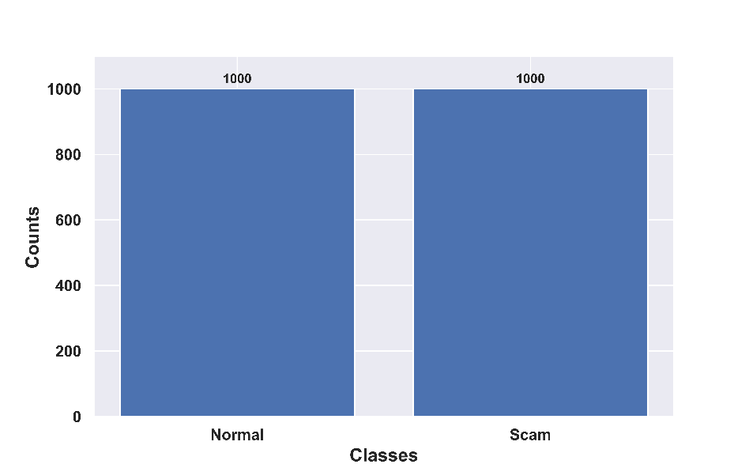

Figure 5. Visualization of the Face Forensics++ dataset with classes

5.3 Performance Metrics
The metrics used for the performance evaluation are formulated and described below in Table 1.
Table 1. Evaluation metrics
Metrics | Expression
Accuracy
Sensitivity
Specificity

Here, ,implies the true positive and negative results and ,implies the false positive and negative results respectively.
5.4 Experimental Results
The experimental results of the SMA-CLMPNet on the Face Forensics++ dataset are illustrated in Figure 6. The experiment is processed through various phases, to determine the difference and detect the forgery by two classes normal and scam.
Face Forensics++ Dataset | Video-1 |  | Video-2
 | Frame-1 | Frame-2 | Frame-1 | Frame-2
Input image |  |  |  | 
Image after preprocessing |  |  |  | 
Grad-CAM features |  |  |  | 
ResNet based features | 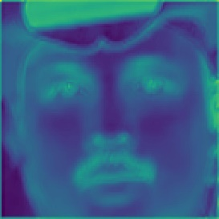 | 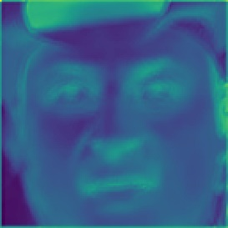 | 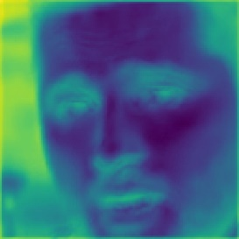 | 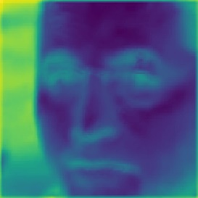
Mean | 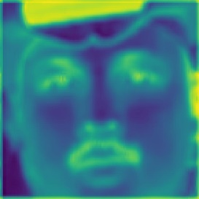 | 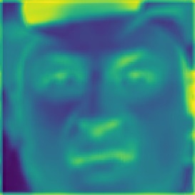 | 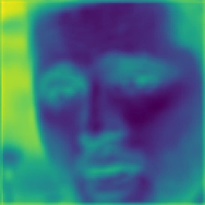 | 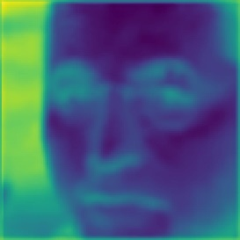
Variance | 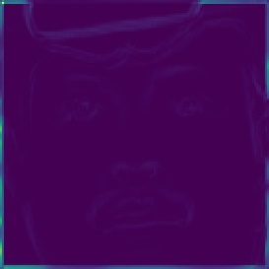 | 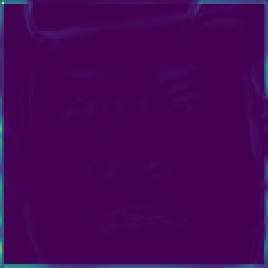 | 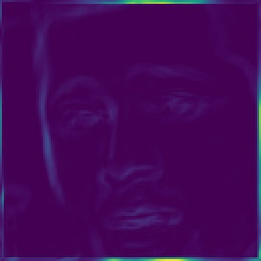 | 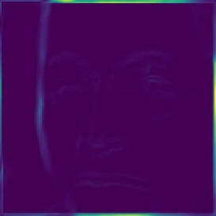
Standard deviation | 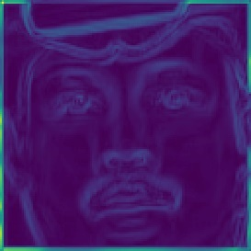 | 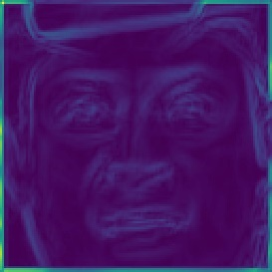 | 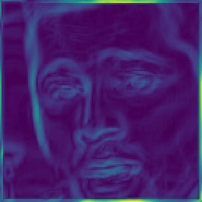 | 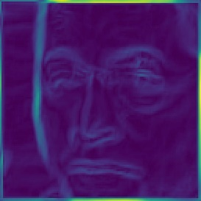
Skewness | 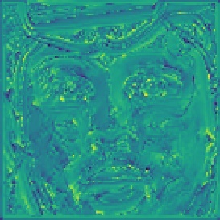 | 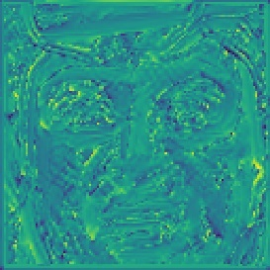 | 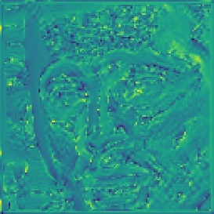 | 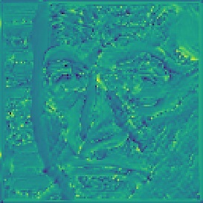
Kurtosis | 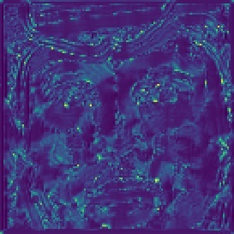 | 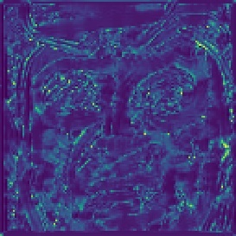 | 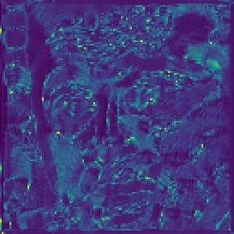 | 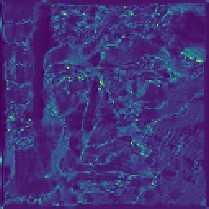
VGG based features |  | 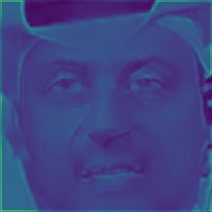 |  | 
LDZP based features | 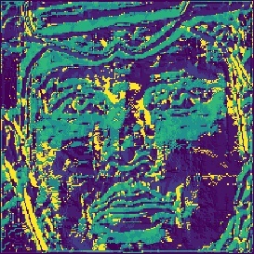 | 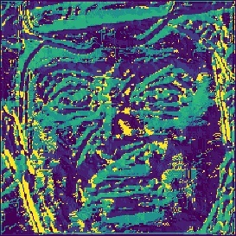 | 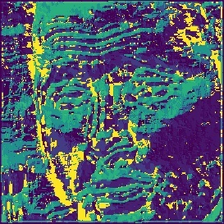 | 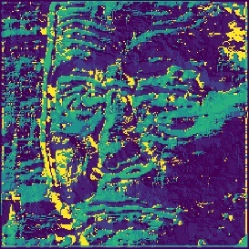
Optical flow features | 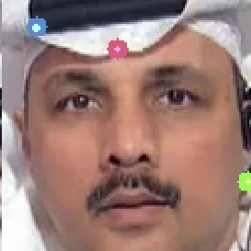 |  |  | 
Output image |    |    |    |   


Figure 6. Experimental results of SMA-CLMPNet using Face Forensics ++ dataset
5.5 Performance Analysis
The performance of the SMA-CLMPNet is measured with differing training percentages and the k-fold value using the FaceForensiscs++ dataset and is discussed below.
5.5.1 Performance evaluation based on Training percentage using FaceForensics++ dataset
The performance of the SMA-CLMPNet is calculated by varying the training percentages along the epoch count of 100,200,300,400, and 500. The proposed model when evaluated for accuracy at a training percentage of 90%, the SMA-CLMPNet acquired an accuracy rate of 90.29% at epoch 100, 92.09% at epoch 200, 93.44% at epoch 300, 95.49% at epoch 400, and 97.92% at epoch 500. Subsequently, for the 100 epochs, the SMA-CLMPNet gained a sensitivity of 90.98% which alternatively upgrades as the increase in epochs by acquiring 93.08%, 93.94%, 95.05%, and 97.34% at epochs 200,300,400, and 500 respectively. Finally, when measured for the specificity, the proposed framework at 90% percent of training, showed a specificity of 89.94% for 100 epoch, 91.59% for 200 epoch, 93.19% for 300 epoch, 95.71% for 400 epoch, and 98.20% for 500 epoch respectively. However, it is seen that with the increase in epochs, the performance of the SMA-CLMPNet elevates. Additionally, for efficient performance in detecting forgery, 90% of data is allotted for training and the remaining 10% undergoes for testing the model. The performance evaluation of the SMA-CLMPNet with differing training percentages is visualized through the graphical representation in Figure 7.

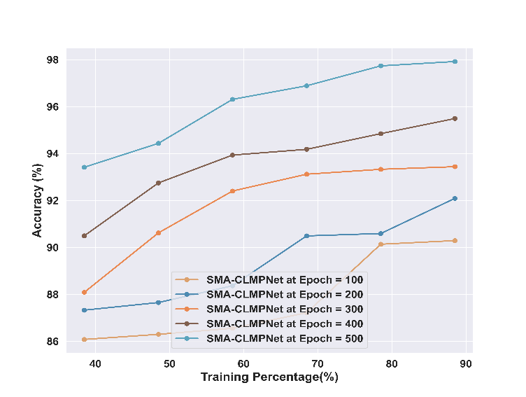 | 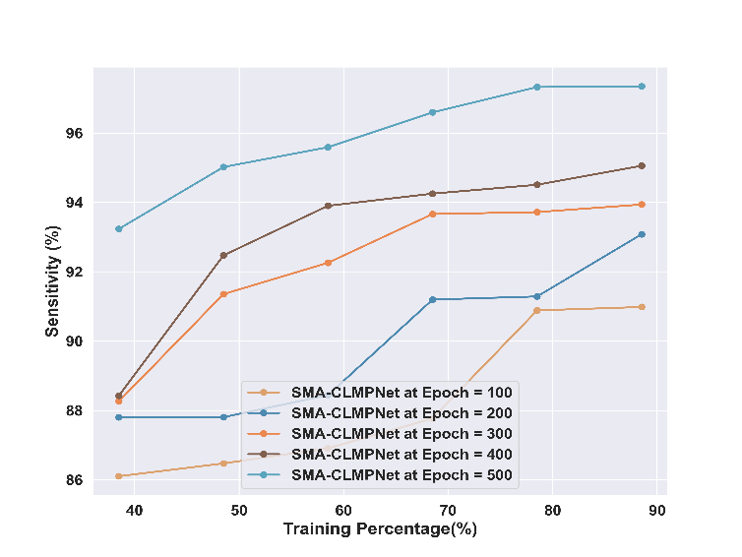
Accuracy | Sensitivity
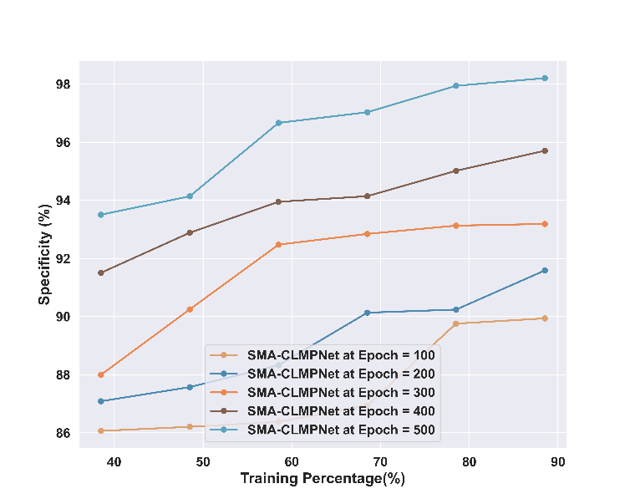

Specificity
Figure 7. Performance evaluation based on varying training percentage
5.5.2 Performance evaluation based on K-fold using FaceForensics++ dataset
The evaluation of the performance by varying the values of k-fold using the Face Forensics++ dataset is illustrated in Figure 8. The k-fold value of 6,7,8,9,10 is validated against metrics like accuracy, sensitivity, and specificity to determine the superiority. Initially, the SMA-CLMPNet showcased an accuracy of 89.61% at 100 epoch at the k-fold value of 10, with a rise of 92.88% of accuracy at epoch 200, 93.64% at epoch 300, 95.27% at epoch 400, and 96.96% at epoch 500, the model demonstrated profound performance. Similarly, at an epoch rate of 100, the sensitivity of 89.75% attained by the proposed framework, which further increases to 93.58% at 200 epoch, 93.90% at epoch 300, 95.14% at epoch 400, and 96.43% at epoch 500. The specificity of 89.54%, 92.52%, 93.50%, and 95.33% is attained at epochs 100,200,300,400 and the superior specificity of 97.23% is achieved at epoch 500 showcasing that the model is suitable for detecting forgeries.

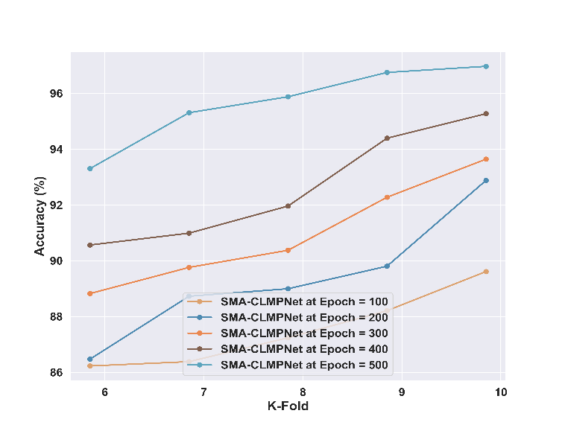 | 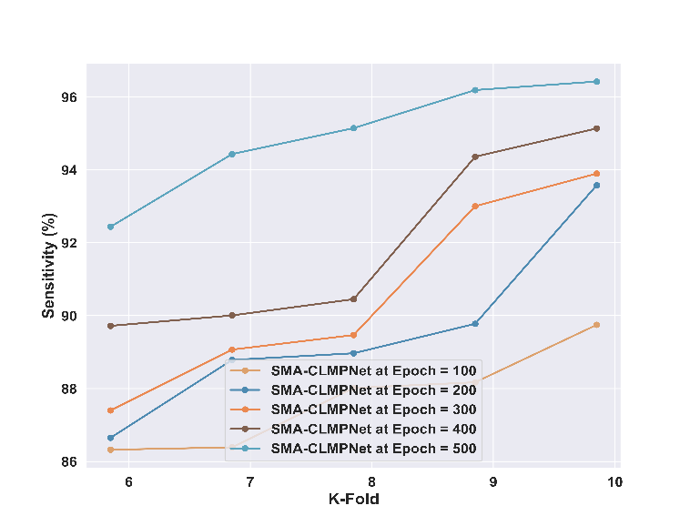
Accuracy | Sensitivity
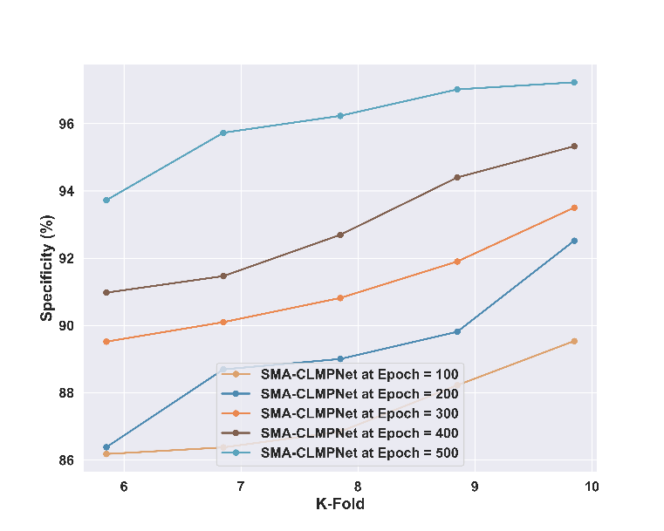

Specificity

Figure 8. Performance evaluation based on varying k-fold values
5.6 Comparative Methods
The SMA-CLMPNet compares the results with other established methods like STIDNet [2], GLCM [7], BA-TFD [6], EfficientNet [5], DCNN [3], SCAM-CLMPNet [28], MUSE-CLMPNet [30] to showcase the effective performance of the proposed model.
5.6.1 Comparison of SMA-CLMPNet based on Training Percentage using FaceForensics++ dataset
The comparison of the SMA-CLMPNet with existing approaches by varying training percentages from 40% to 90% using the Face Forensics++ dataset is demonstrated in Figure 9. For the 90% of training percent, the SMA-CLMPNet attained an accuracy of 97.92% whereas other established methods like EfficientNet attained 95.04%, STIDNet attained 95.07%, DCNN attained 96%, GLCM attained 96.15%, BA-TFD attained 96.29%, MUSE-CLMPNet attained 96.85%, and the SCAM-CLMPNet attained 97.165% which is increased over 2.13%, 2.10%, 1.19%, 0.92%, 0.37%, and 0.06% over the SMA-CLMPNet. Similarly, for the specificity metric, the SMA-CLMPNet acquired sensitivity of 97.34% which is higher compared to 97.22% of EfficientNet, 92.57% of STIDNet, 96.57% of DCNN, 97.07% of GLCM, 97.09% of BA-TFD, 97.25% of MUSE-CLMPNet, and 97.33% of SCAM-CLMPNet by acquiring a difference rate of 0.12%, 4.65%, 0.76%, 0.27%, 0.25%, 0.09%, and 0.02% against the SMA-CLMPNet. Finally, for specificity the proposed approach gained a specificity of 98.20% at 90% training percent. Meanwhile, other approaches like EfficientNet, STIDNet, DCNN, GLCM, BA-TFD, MUSE-CLMPNet, SCAM-CLMPNet, and the SMA-CLMPNet achieved 97.95%, 95.65%, 96.76%, 97.49%, 97.67%, 97.80%, and 97.89% which is 0.25%, 2.51%, 1.42%, 0.70%, 0.52%, 0.40%, and 0.31% high when comparing with proposed SMA-CLMPNet.
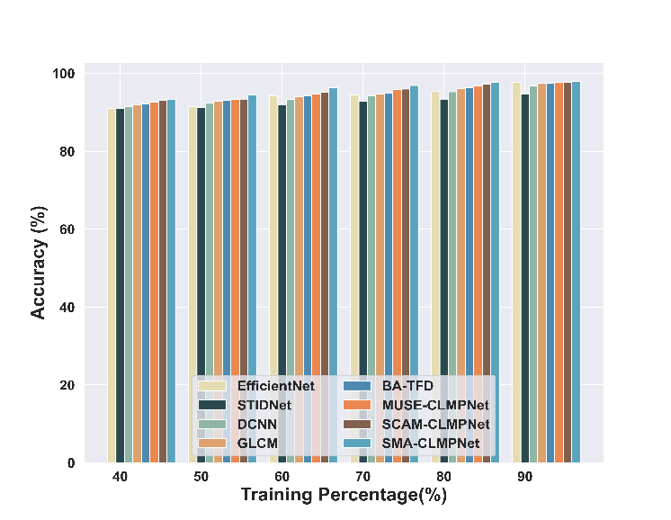 | 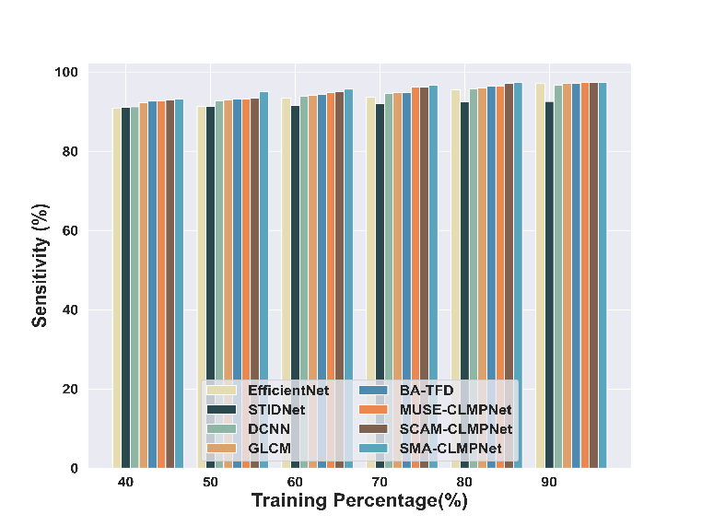
Accuracy | Sensitivity
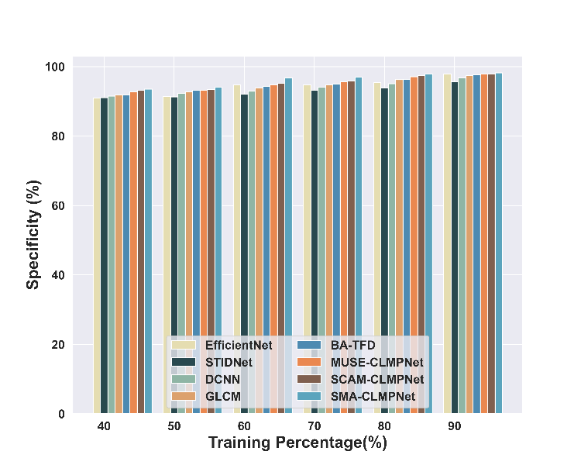

Specificity

Figure 9. Comparative Analysis of SMA-CLMPNet with varying training percentage using Face Forensics ++ dataset
5.6.2 Comparison of SMA-CLMPNet based on K-fold using FaceForensics++ dataset
The SMA-CLMPNet is compared with existing methods by different k-fold values of 6,7,8,9, and 10 using the Face Forensics++ dataset, and the graphical representation is depicted in Figure 10. At the k-fold 10, the SMA-CLMPNet achieved a 96.96% accuracy, which is superior when compared against 95.17% of EfficientNet, 95.29% of STIDNet, 95.97% of DCNN, 96.07% of GLCM, 96.18% of BA-TFD, 96.57% of MUSE-CLMPNet, and 96.87% of SCAM-CLMPNet by attaining a difference of 1.74%, 1.62%, 0.97%, 0.86%, 0.76%, 0.38%, 0.09% with the proposed approach respectively. For the sensitivity metric, the superior value gained by the SMA-CLMPNet is 96.43% at k-fold value of 10, where other methods like EfficientNet achieved 95.43%, STIDNet achieved 95.74%, DCNN achieved 95.89%, GLCM achieved 95.92%, BA-TFD achieved 95.98%, MUSE-CLMPNet achieved 96.02%, and the SCAM-CLMPNet achieved 96.28%, that showcases 0.96%, 0.66%, 0.52%, 0.49%, 0.43%, 0.39%, and 0.14% difference over proposed method. Subsequently, for k-fold 10, the proposed SMA-CLMPNet showed 97.23% specificity, while the EfficientNet, STIDNet, DCNN, GLCM, BA-TFD, MUSE-CLMPNet, SCAM-CLMPNet, and the SMA-CLMPNet achieved 95.04%, 95.07%, 96%, 96.15%, 96.29%, 96.85%, and 97.16%. The proposed framework showed differences of 2.13% over EfficientNet, 2.10% over STIDNet, 1.19% over DCNN, 1.05% over GLCM, 0.92% over BA-TFD, 0.37% over MUSE-CLMPNet, and 0.06 over SCAM-CLMPNet, respectively.
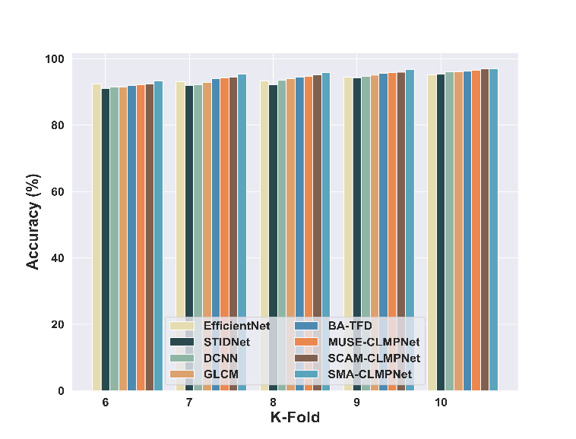 | 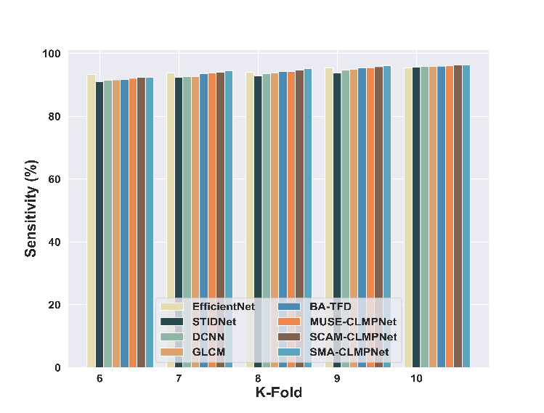
Accuracy | Sensitivity
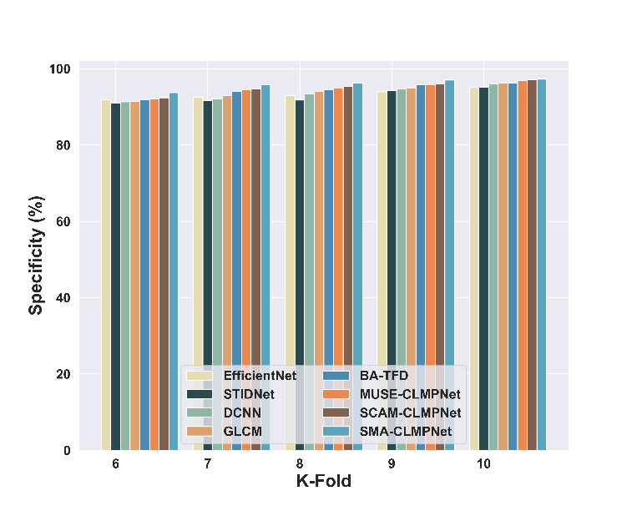

Specificity
Figure 10. Comparative Analysis of SMA-CLMPNet with varying k-fold values using Face Forensics ++ dataset
5.7 Feature Analysis
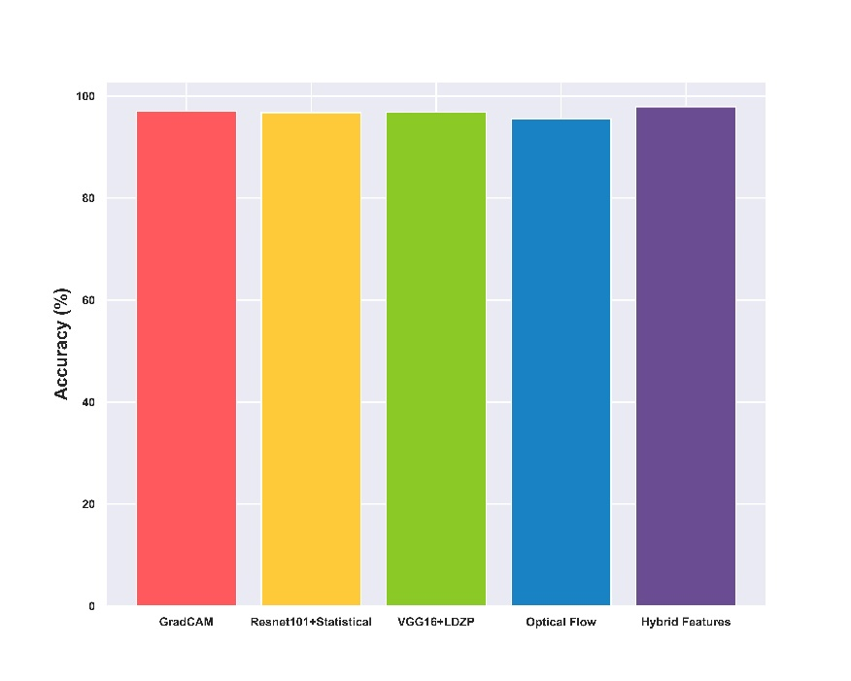
The feature analysis of the SMA-CLMPNet is carried out for the utilized features based on the accuracy where the Grad-CAM achieved 97.02%, ResNet 101-based Statistical features achieved 96.76%, VGG16-based LDZP features achieved 96.86%, Optical flow achieved 95.58%, and collectively hybrid features acquired 97.92%. The performance of the features based on the accuracy is illustrated in Figure 11.

Figure 11. Feature Analysis based on the Accuracy
5.8 Statistical Analysis
The statistical analysis of the SMA-CLMPNet with the existing approaches using the Face Forensics++ dataset is depicted in Table 2. The analysis showcases the best, mean, and variance values attained by the methods with the training percentage of 90% and k-fold value of 10 along the metrics.
Table 2. Statistical Analysis of the SMA-CLMPNet using Face Forensics++ Dataset
Methods vs Attained Results |  | FaceForensics++ Dataset
 |  | Training Percent (90%)
 |  | EfficientNet | STIDNet | DCNN | GLCM | SA-TFD | MUSE-CLMPNet | SCAM-CLMPNet | SMA-CLMPNet
Best | Accuracy (%) | 97.71 | 94.64 | 96.69 | 97.35 | 97.48 | 97.62 | 97.70 | 97.92
 | Sensitivity (%) | 97.22 | 92.57 | 96.57 | 97.07 | 97.09 | 97.25 | 97.33 | 97.34
 | Specificity (%) | 97.95 | 95.65 | 96.76 | 97.49 | 97.67 | 97.80 | 97.89 | 98.20
Mean | Accuracy (%) | 94.03 | 92.52 | 93.88 | 94.46 | 94.73 | 95.17 | 95.45 | 96.11
 | Sensitivity (%) | 93.65 | 91.79 | 94.10 | 94.47 | 94.69 | 95.06 | 95.32 | 95.85
 | Specificity (%) | 94.22 | 92.88 | 93.77 | 94.46 | 94.74 | 95.22 | 95.51 | 96.25
Variance | Accuracy (%) | 5.30 | 1.56 | 3.11 | 3.47 | 3.28 | 3.22 | 3.11 | 2.77
 | Sensitivity (%) | 4.82 | 0.30 | 3.17 | 2.81 | 2.62 | 2.90 | 2.93 | 2.09
 | Specificity (%) | 5.63 | 2.56 | 3.15 | 3.82 | 3.66 | 3.43 | 3.23 | 3.24
 |  | K-fold Value= 10
 |  | EfficientNet | STIDNet | DCNN | GLCM | SA-TFD | MUSE-CLMPNet | SCAM-CLMPNet | SMA-CLMPNet
Best | Accuracy (%) | 95.17 | 95.29 | 95.97 | 96.07 | 96.18 | 96.57 | 96.87 | 96.96
 | Sensitivity (%) | 95.43 | 95.74 | 95.89 | 95.92 | 95.98 | 96.02 | 96.28 | 96.43
 | Specificity (%) | 95.04 | 95.07 | 96.00 | 96.15 | 96.29 | 96.85 | 97.16 | 97.23
Mean | Accuracy (%) | 93.68 | 92.92 | 93.55 | 93.90 | 94.41 | 94.68 | 94.96 | 95.64
 | Sensitivity (%) | 94.44 | 93.17 | 93.66 | 93.82 | 94.19 | 94.33 | 94.66 | 94.93
 | Specificity (%) | 93.29 | 92.79 | 93.50 | 93.93 | 94.52 | 94.86 | 95.11 | 95.99
Variance | Accuracy (%) | 0.98 | 2.45 | 2.76 | 2.57 | 2.25 | 2.27 | 2.30 | 1.72
 | Sensitivity (%) | 0.67 | 2.40 | 2.35 | 2.41 | 2.25 | 1.95 | 1.88 | 2.06
 | Specificity (%) | 1.19 | 2.59 | 2.99 | 2.67 | 2.26 | 2.46 | 2.54 | 1.57

5.9 Confusion Matrix
The confusion matrix is summarized by considering the performance of the detection system. The performance is measured along the Normal and Scam classes of both predicted and true labels to determine accurate detections. Figure 12. depicts the confusion matrix of the SMA-CLMPNet framework.
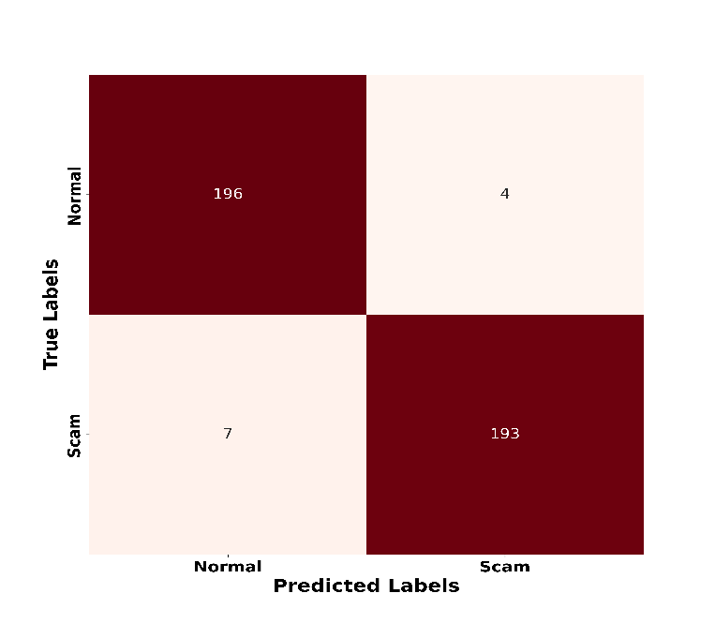

Figure 12. Confusion Matrix of the SMA-CLMPNet
5.10 ROC Analysis
The Region of Curve (ROC) analysis of the SMA-CLMPNet is illustrated in Figure 13. The analysis is performed by comparing the true positive rate against the false positive rate. For the false positive rate of 0.7, the SMA-CLMPNet gained 0.97 of true positive rate, whereas the EfficientNet, STIDNet, DCNN, GLCM, BA-TFD, MUSE-CLMPNet, SCAM-CLMPNet gained 0.87, 0.92,0.92, 0.93, 0.94, 0.94, 0.95, and 0.95 respectively.
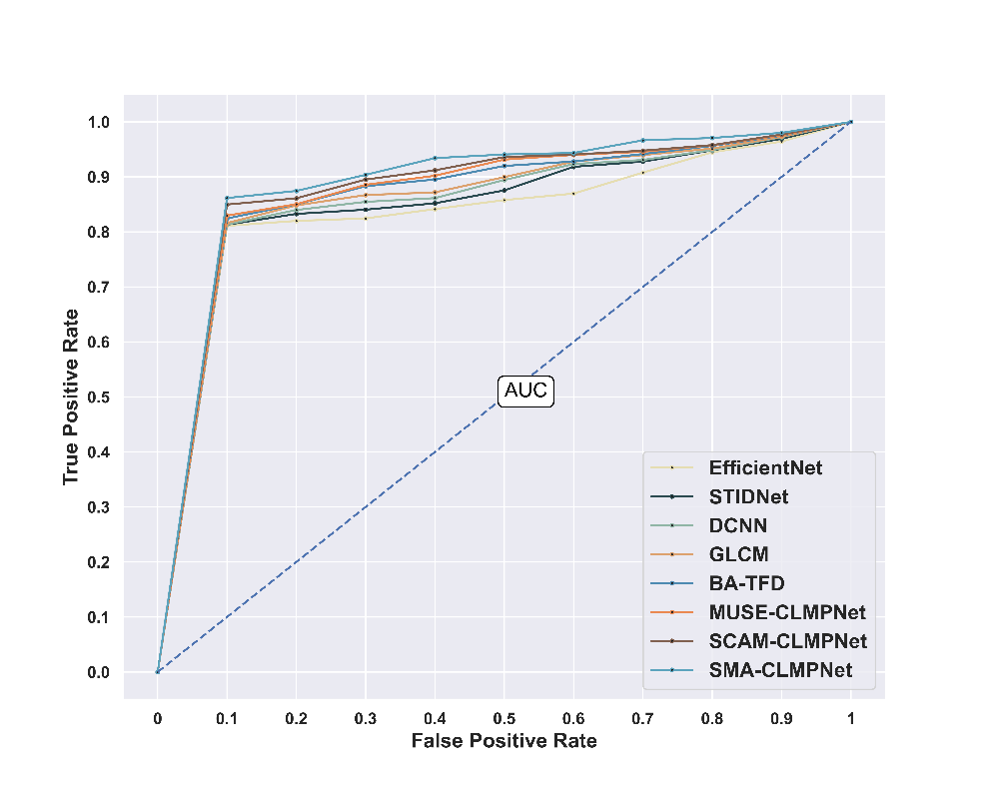

Figure 13. ROC Analysis of the SMA-CLMPNet
5.11 Comparative Discussion
The extensive use of video data through social media platforms enhanced the risk of manipulation and misuse. Though several approaches are used for detecting the risks involved, every method still shows some drawbacks that hinder their performance. The STIDNet [2] effectively detects identity-aware face forgeries but faces challenges while maximizing the extraction models to leverage more discriminative characteristics, which reduces the accuracy against different forgery techniques. The DCNN [3] in video forensics captures the diverse patterns in data, but lacks localization of the forged regions of the manipulated frames, particularly in low bit-rate and low-resolution sequences of the video. The Efficient Net [5] delivers a sophisticated range of detecting deepfake videos. However, the model due to its less generalization, found it difficult to distinguish between the real and the high-quality forged faces, and leads to misidentification. While the GLCM [7] flawlessly detects duplication of frames, that are prevalent in the forgery operations, but the model struggles with detecting the insertion of inter-frame and deleted manipulations thereby producing more false positives and negatives. The BA-TFD [6] creates audio reenactment for detecting forgery in high-resolution frames. However, this technique developed constraints in generating reference styles and required more refinement which hindered the overall performance along with introducing computational complexities. The existing approaches utilized for comparison inherit diverse limitations that are effectively tackled by the CLMPNet by introducing attention mechanisms to capture dependencies and distributed LSTM in the network to effectively detect unnatural facial movements through sequential learning. Table 3. depicts the comparative results obtained by SMA-CLMPNet demonstrating superior results in comparison with other approaches.
Table 3. Comparative discussion of the SMA-CLMPNet
Methods | Face Forensics++ Dataset
 | Training Percentage=90% |  |  | K-fold=10
 | Accuracy  % | Sensitivity  % | Specificity  % | Accuracy  % | Sensitivity  % | Specificity  %
EfficientNet | 97.71 | 97.22 | 97.95 | 95.17 | 95.43 | 95.04
STIDNet | 94.64 | 92.57 | 95.65 | 95.29 | 95.74 | 95.07
DCNN | 96.69 | 96.57 | 96.76 | 95.97 | 95.89 | 96.00
GLCM | 97.35 | 97.07 | 97.49 | 96.07 | 95.92 | 96.15
BA-TFD | 97.48 | 97.09 | 97.67 | 96.18 | 95.98 | 96.29
MUSE-CLMPNet | 97.62 | 97.25 | 97.80 | 96.57 | 96.02 | 96.85
SCAM-CLMPNet | 97.70 | 97.33 | 97.89 | 96.87 | 96.28 | 97.16
SMA-CLMPNet | 97.92 | 97.34 | 98.20 | 96.96 | 96.43 | 97.23

6. Conclusion
The research introduces an intra-frame video forgery enhancement framework called the SMA-CLMPNet incorporating SMA attention mechanisms, distributed LSTM in the system along with modified pooling strategies. The SMA includes the SCAM attention which improves the feature refinement by minimizing the inconsistencies along the spatial and channel dimensions. Meanwhile, MUSE attention effectively forms the SMA that improves the model’s ability to detect the global and local artifacts available in the forged videos. Furthermore, the distributed LSTM in the convolutional network captures long-range dependencies that make the identification of manipulated frames easier. Additionally, a modified pooling enhances flexibility and a more robust representation of features. Collectively, SMA-CLMPNet combines these elements and facilitates the effective detection of forgeries. Experiments were conducted on the Face Forensics++ dataset, where the SMA-CLMPNet achieved a 97.92% accuracy, 97.34% sensitivity, and 98.20% specificity at the training percentage of 90%. Similarly, for the k-fold value of 10, the proposed approach attains 96.96% accuracy, 96.43% sensitivity, and 97.23% specificity respectively demonstrating its effectiveness in detecting video forgeries. Future directions will include the development of SMA-CLMPNet for multimodal forgery detection, enhanced adversarial robustness, and increased interpretability. Additionally, the research will explore cross-dataset generalization and integrate new deepfake generation approaches to improve the detection.
References
[1] Kaur, H. and Jindal, N., 2020. Deep convolutional neural network for graphics forgery detection in video. Wireless Personal Communications, 112(3), pp.1763-1781.
[2] Fang, M., Yu, L., Xie, H., Tan, Q., Tan, Z., Hussain, A., Wang, Z., Li, J. and Tian, Z., "STIDNet: Identity-aware face forgery detection with spatiotemporal knowledge distillation", IEEE Transactions on Computational Social Systems, 2024.
[3] Mazhar, A.A., Jameel, A., Nadeem, M., Khan, M.A.U., Alkhateeb, J.H., Bibi, F. and Seerat, A.M., "Deep Convolutional Neural Network for Robust Detection of Object-Based Forgeries in Advanced Video", IEEE Access, 2024.
[4] Li, Q., Wang, R. and Xu, D., "A video splicing forgery detection and localization algorithm based on sensor pattern noise", Electronics, vol12, no.6, pp.1362, 2023.
[5] Zhang, D., Chen, J., Liao, X., Li, F., Chen, J. and Yang, G., "Face forgery detection via multi-feature fusion and local enhancement", IEEE Transactions on Circuits and Systems for Video Technology, 2024.
[6] Cai, Z., Ghosh, S., Dhall, A., Gedeon, T., Stefanov, K. and Hayat, M., "Glitch in the matrix: A large scale benchmark for content driven audio–visual forgery detection and localization", Computer Vision and Image Understanding, 236, p.103818, 2023.
[7] Li, L., Lu, J., Zhang, S., Mohaisen, L. and Emam, M., "Frame Duplication Forgery Detection in Surveillance Video Sequences Using Textural Features", Electronics, vol.12, no.22, pp.4597, 2023.
[8] Zhang, D., Xiao, Z., Li, S., Lin, F., Li, J. and Ge, S., "Learning natural consistency representation for face forgery video detection", In European Conference on Computer Vision, Springer, Cham, pp. 407-424, 2025.
[9] Eltoukhy, M.M., Alsubaei, F.S., Mortda, A.M. and Hosny, K.M., "An efficient convolution neural network method for copy-move video forgery detection", Alexandria Engineering Journal, vol.110, pp.429-437, 2025.
[10] Kaur, H. and Jindal, N., "Image and video forensics: A critical survey", Wireless Personal Communications, vol.112, no.2, pp.1281-1302, 2020.
[11] Abhishek and Jindal, N., "Copy move and splicing forgery detection using deep convolution neural network, and semantic segmentation", Multimedia Tools and Applications, vol.80, no.3, pp.3571-3599, 2021.
[12] Dhiman, N., Singh, H. and Thakur, A., "An Extensive Approach for Inter-Frames Video Forgery Detection", In International Conference on Electrical and Electronics Engineering, Springer Nature Singapore, pp. 333-345, August 2023.
[13] Dhiman, N., Singh, H. and Thakur, A., "An Efficient Approach for Image Forgery Detection Using Deep Convolutional Neural Network", IEEE International Conference on Electrical, Electronics, Communication, and Computers, pp.1-5, August 2023.
[14] Kaur, H. and Jindal, N., "Deep convolutional neural network for graphics forgery detection in video", Wireless Personal Communications, vol.112, no.3, pp.1763-1781, 2020.
[15] Su, L., Luo, H. and Wang, S., "A novel forgery detection algorithm for video foreground removal", IEEE Access, vol.7, pp.109719-109728, 2019.
[16] Singh, A., Singh, G. and Singh, K., "A Markov based image forgery detection approach by analyzing CFA artifacts", Multimedia Tools and Applications, vol.77, pp.28949-28968, 2018.
[17] Yuan, Y., Yang, X., Wu, W., Li, H., Liu, Y. and Liu, K., "A fast single-image super-resolution method implemented with CUDA", Journal of Real-Time Image Processing, vol.16, pp.81-97, 2019.
[18] Tyagi, S. and Yadav, D., 2023. A detailed analysis of image and video forgery detection techniques. The Visual Computer, 39(3), pp.813-833.
[19] Gharahbagh, A.A., Hajihashemi, V., Ferreira, M.C., Machado, J.J. and Tavares, J.M.R., 2022. Best frame selection to enhance training step efficiency in video-based human action recognition. Applied Sciences, 12(4), p.1830.
[20] Chaudhari, M.N., Deshmukh, M., Ramrakhiani, G. and Parvatikar, R., 2018, August. Face detection using viola jones algorithm and neural networks. In 2018 Fourth International Conference on Computing Communication Control and Automation (ICCUBEA) (pp. 1-6). IEEE.
[21] Selvaraju, R.R., Cogswell, M., Das, A., Vedantam, R., Parikh, D. and Batra, D., 2020. Grad-CAM: visual explanations from deep networks via gradient-based localization. International journal of computer vision, 128, pp.336-359.
[22] Haloi, R., Hazarika, J. and Chanda, D., 2020, July. Selection of appropriate statistical features of EEG signals for detection of Parkinson’s disease. In 2020 International Conference on Computational Performance Evaluation (ComPE) (pp. 761-764). IEEE.
[23] Roy, S.K., Chanda, B., Chaudhuri, B.B., Banerjee, S., Ghosh, D.K. and Dubey, S.R., 2018. Local directional ZigZag pattern: A rotation invariant descriptor for texture classification. Pattern Recognition Letters, 108, pp.23-30.
[24] Sun, S., Kuang, Z., Sheng, L., Ouyang, W. and Zhang, W., 2018. Optical flow guided feature: A fast and robust motion representation for video action recognition. In Proceedings of the IEEE conference on computer vision and pattern recognition (pp. 1390-1399).
[25] Zhao, L. and Zhang, Z., 2024. A improved pooling method for convolutional neural networks. Scientific Reports, 14(1), p.1589.
[26] Korschens, M., Bodesheim, P. and Denzler, J., 2022, December. Beyond Global Average Pooling: Alternative Feature Aggregations for Weakly Supervised Localization. In VISIGRAPP (4: VISAPP) (pp. 180-191).
[27] Wen, G., Qin, J., Fu, X. and Yu, W., 2021. DLSTM: Distributed long short-term memory neural networks for the Internet of Things. IEEE Transactions on Network Science and Engineering, 9(1), pp.111-120.
[28] Fang, W. and Han, X.H., 2020. Spatial and channel attention modulated network for medical image segmentation. In Proceedings of the Asian conference on computer vision.
[29] Zhao, X., Liu, Y. and Han, G., 2021. Cooperative use of recurrent neural network and siamese region proposal network for robust visual tracking. IEEE Access, 9, pp.57704-57715.
[30] Yao, L., Wang, J. and Zhao, C., 2024. Non-Intrusive Load Monitoring Based on Multiscale Attention Mechanisms. Energies, 17(8), p.1944.
[31] Kaur, N., Jindal, N. and Singh, K., 2020. A passive approach for the detection of splicing forgery in digital images. Multimedia Tools and Applications, 79(43), pp.32037-32063.
[32] FaceForensics++ Dataset, https://www.niessnerlab.org/projects/roessler2019faceforensicspp.html, accessed on March,2025.

